Sal f
Golden Valley High School
Wm. S. Hart Union High School District
“Home of the Grizzlies”
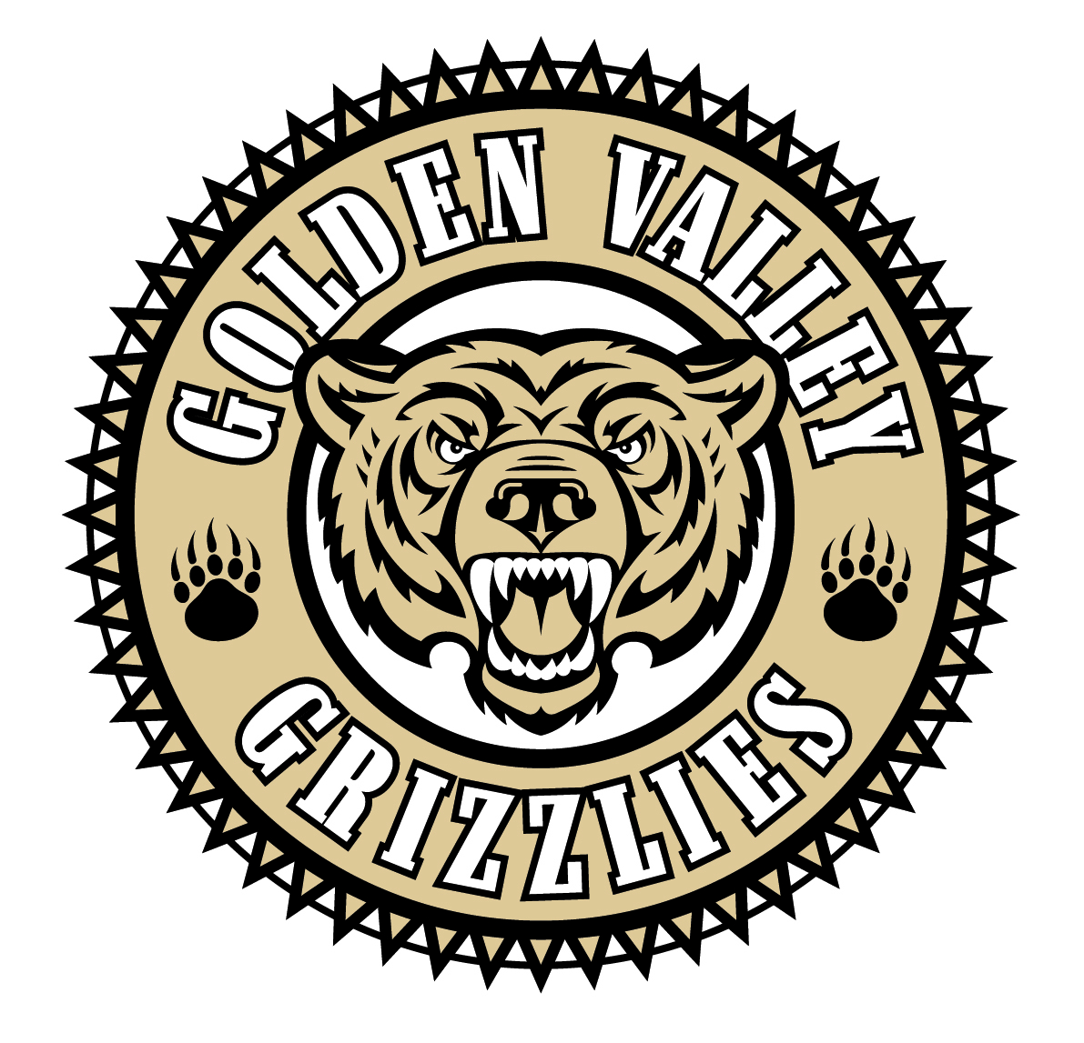
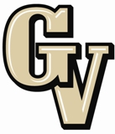

Parent Advisory Council (PAC) Meeting
May 6, 2013
6:00 Dinner
6:30 Meeting Starts

AGENDA

- PAC Meeting Welcome Sal Frias

- Secretary’s Report ACTION Jennifer Ryan

- Treasurer’s Report ACTION Emily Curtis

- President’s Report Sue Alterman

- District Advisory Council (DAC) Report Monica Camacho

- Parent Communications Council (PCC) Report Cherise Moore

- Traffic Flow Changes at GVHS for 2013-14 Richard Varner, District Director of
Transportation

- Foreign Language Department Donny Galland

- PE/ Health Department Adam Yassaman

Announcements: - Teacher Appreciation Breakfast May 9th
-AP Exams started today, May 6th and run through May 17th
-Sports and programs all have banquets this time of year. Check out our calendar.
-Grizzly Band Recital and Spaghetti Dinner on May 11th
-Choir Spring Concert on May 14th
-Spring Band Concert on May 22nd
-Senior Awards is May 23rd at 6:30 pm in the amphitheater
-Graduation is Thursday, May 30th at 7 pm (COC)
-Finals are May 28th through May 30th. (All three are minimum days)
-Grizzly Band Fund Raiser “Sonora Show” on May 31st

Next Meeting: August 26, 2013

The mission of GVHS is to provide a quality education to a diverse student population, develop each student’s maximum potential, and prepare students for success in the global community.

